**Laporan Text Procedure Bahasa Inggris**

Name: Dzaki Al Toriq

Class: XI PPLG B

Present number: 13

1. What is static web?

A static website is a type of website that is composed of individual web pages with fixed, unchanging content. In a static website, each web page is created as a separate HTML file, and the content on these pages remains the same unless manually updated by a web developer or administrator.

1. What is an example of a static web?

* Personal Blogs
* Portfolio Websites
* Landing Pages
* Documentation Sites
* Personal Resumes/CVs
* Business Websites (basic)
* Nonprofit Organizations
* Event Websites
* Educational Websites (simple)
* Government and Institutional Website

1. What kind of website do you make?

A Portfolio Website

**How to make Portfolio Website**

Purpose: Teach people how to make portfolio website

Tools: PC or Laptop

Steps:

1. First, Make folder and add 3 files and give name home.html, about-me.html and my-skills.html

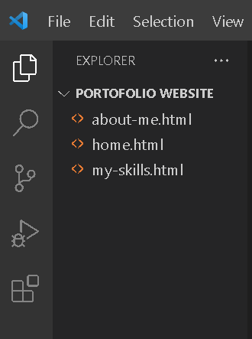

1. Second, on index.html file add navbar, intro and footer

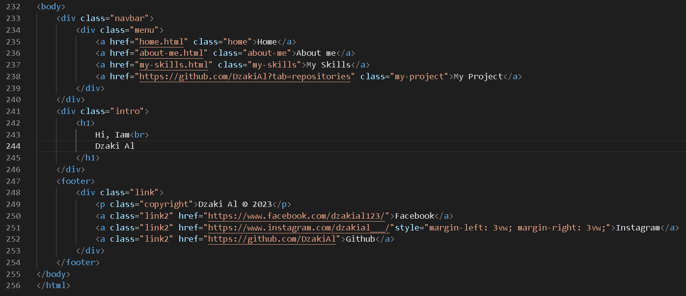

1. 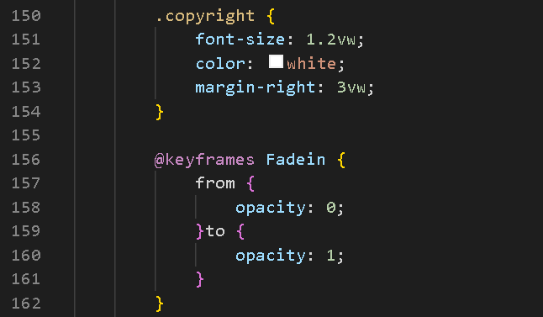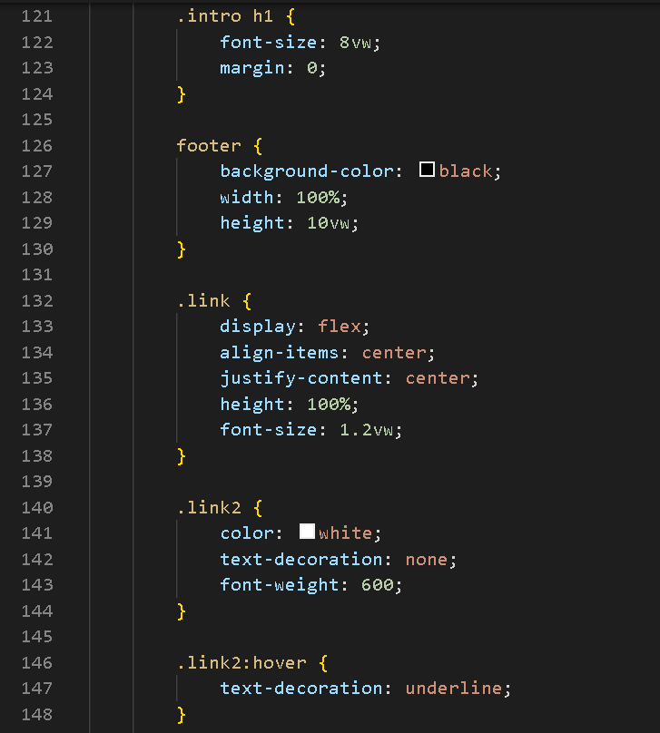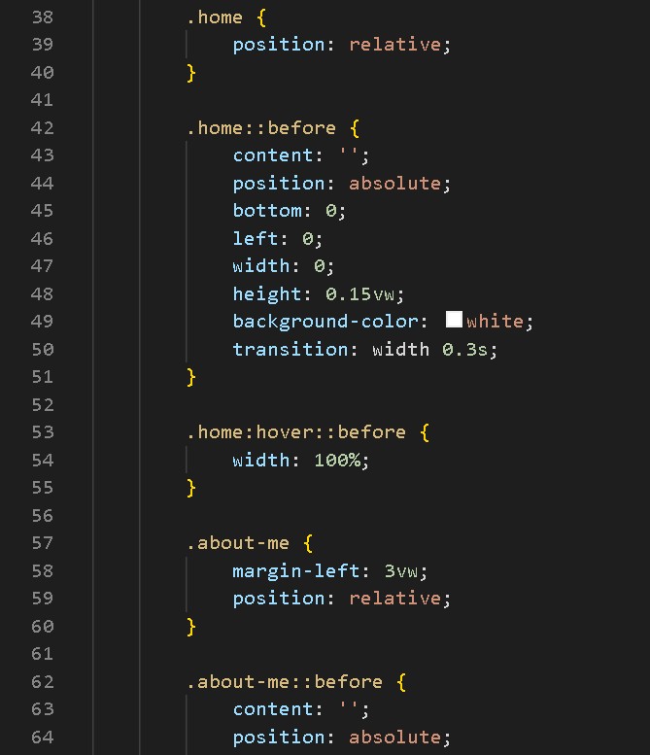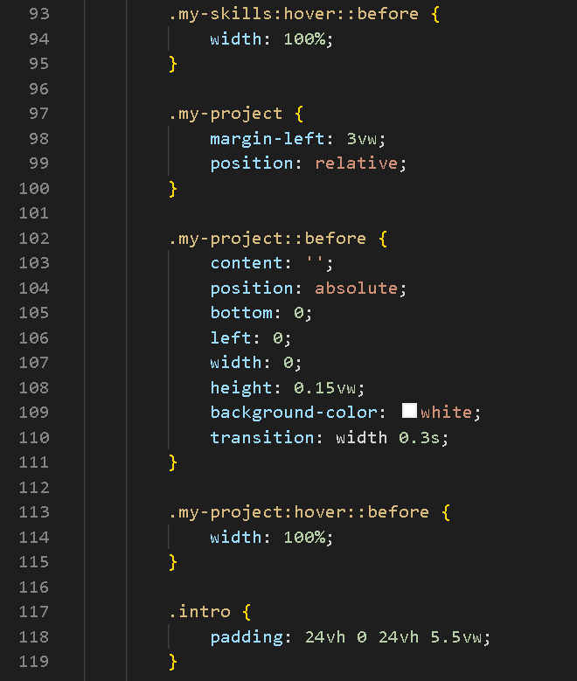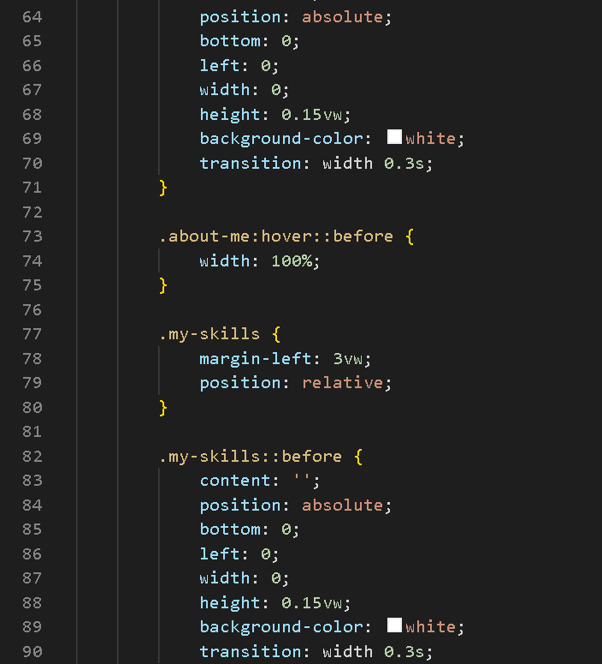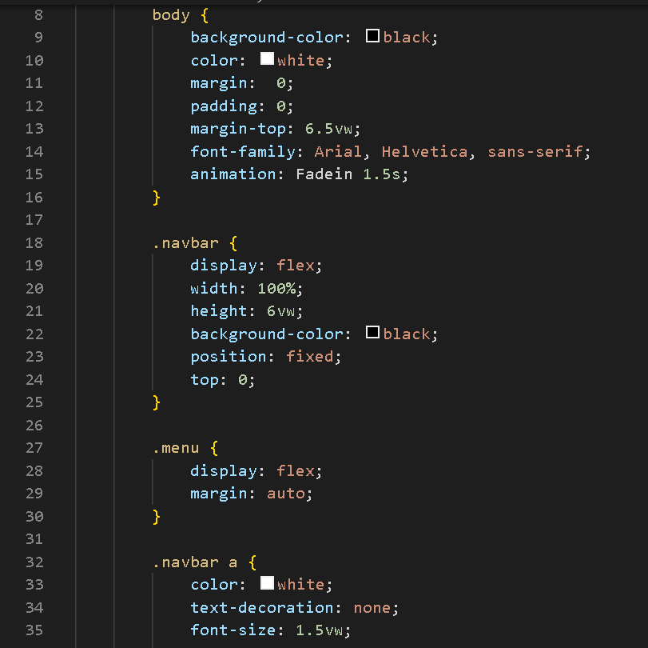Third, add style to the website to make more attractive
2. Fourth, on about-me.html file add navbar, the content and footer

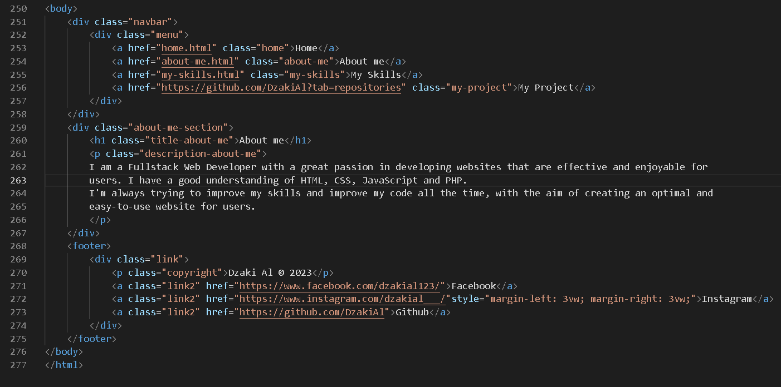

1. 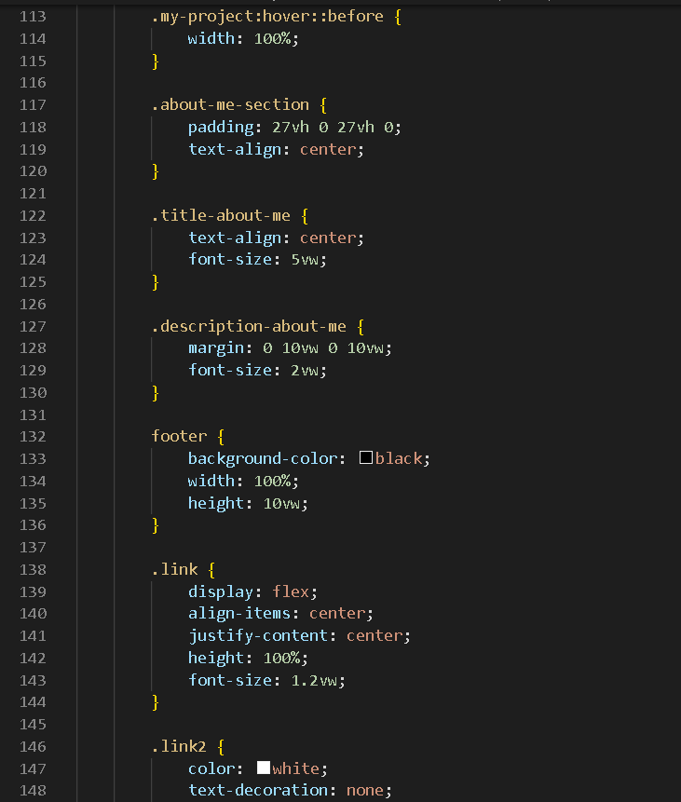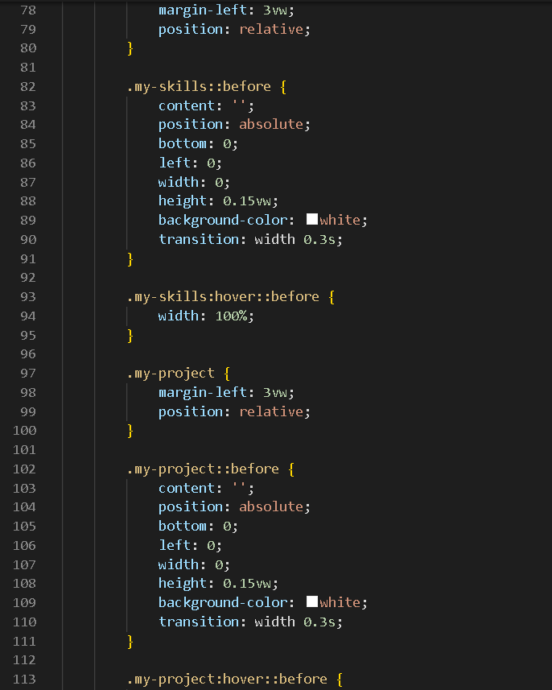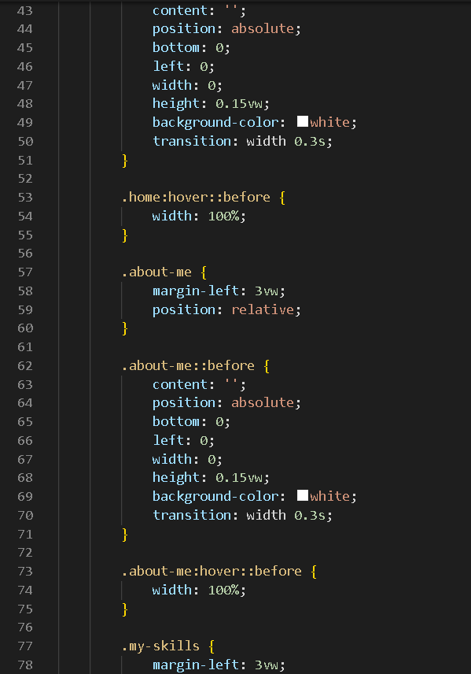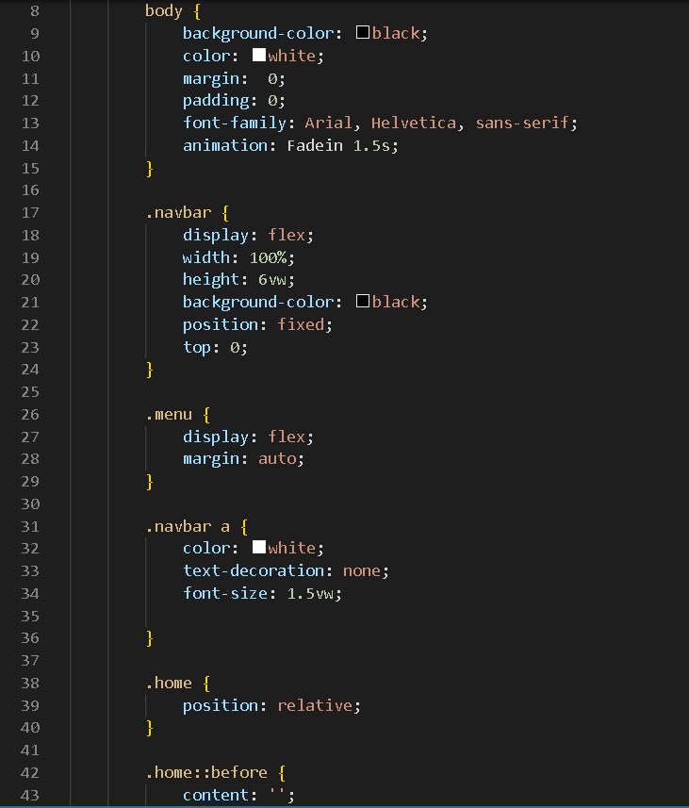Fifth, add style to the website

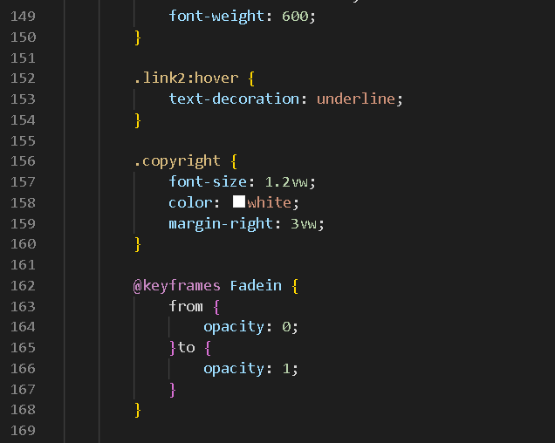

1. 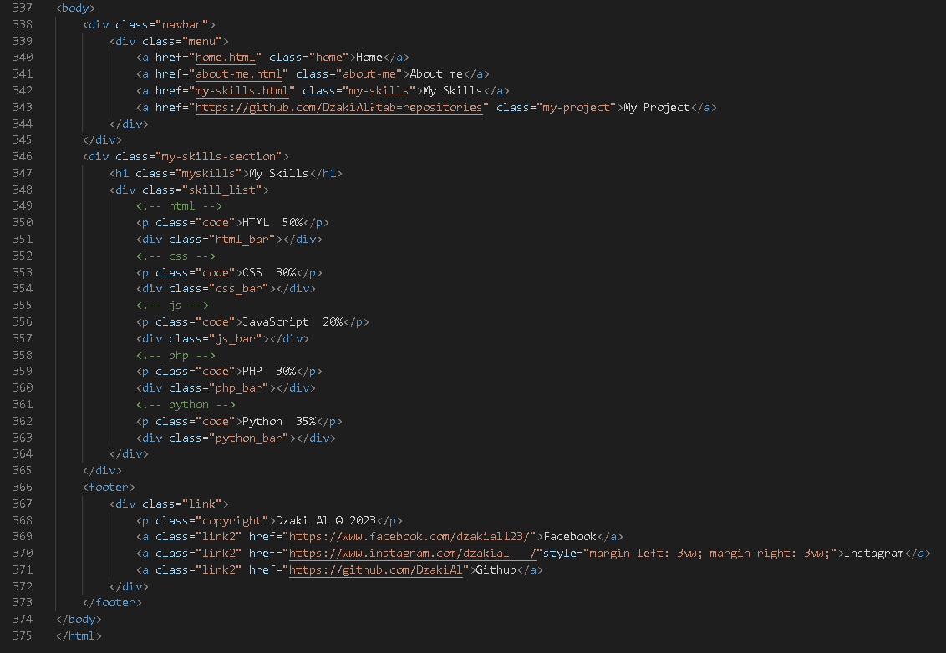Sixth, on my-skills.html file add navbar, the content and footer
2. 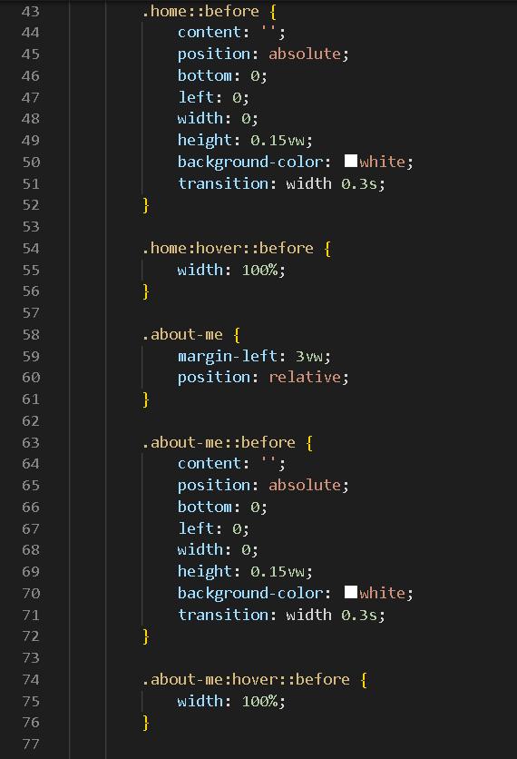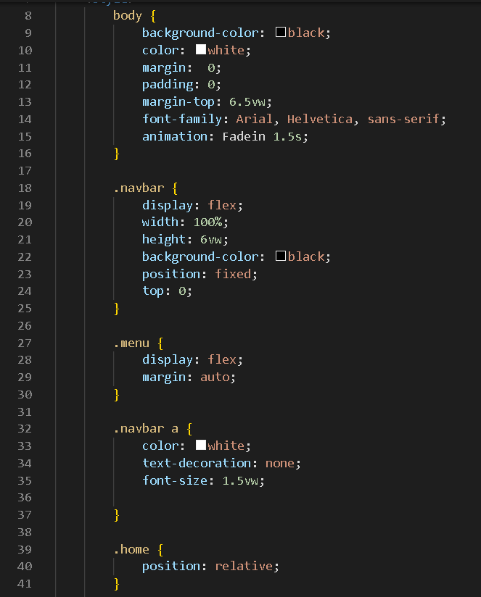Seventh, add style to the website

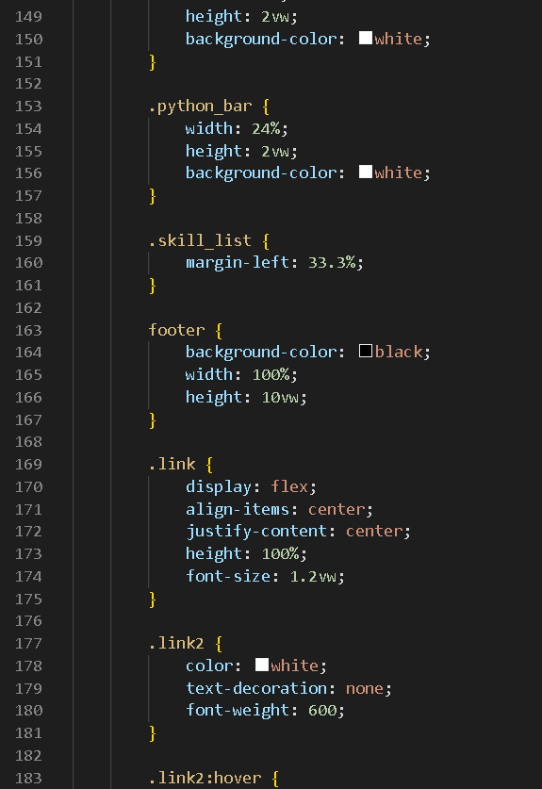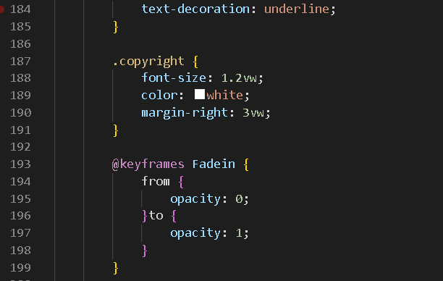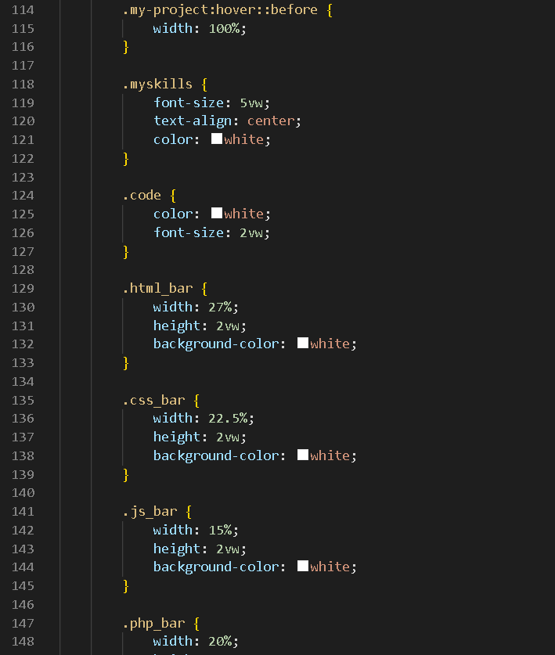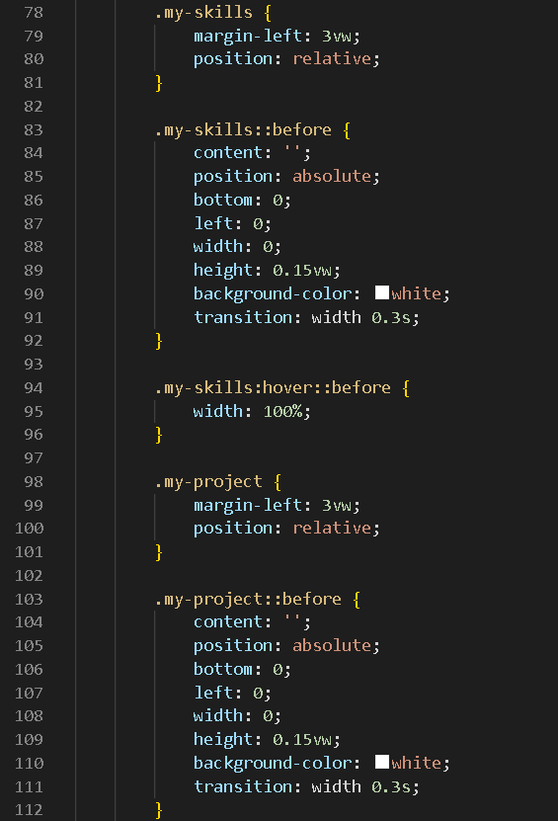

1. 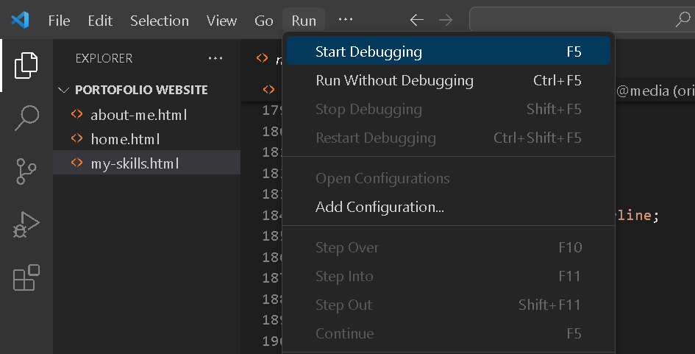Eight, look on top left then search run and start debugging
2. Finally you can see your website how it is like